Physics Lab #3: Mechanical Equivalent of Heat
Charlie Coleman
Lab Partners: Alex Bielewicz, Tracey Jaron
2016 September 14

Abstract: The purpose of this lab was to examine the electrical and heat equivalency of mechanical energy. Through the definitions of electric potential and Ohm's law, we are able to get an equation that equates current, resistance, and time to work. The lab was a success because the calculated percent error was 1.21%, and the maximum percent error to consider the lab a success was 20%, considerably greater than the calculated.

Theory: Electric potential is defined as the work per unit charge. From Ohm's Law, we get the equation V=IR. By substitution, we get the equation. If a current is sent through a coil, the coil will give off the energy in the form of heat. The coil can be submerged in the water and the temperature change can be measured to find the heat in a second manner in order to verify this equation.

Objective: The purpose of this lab was to look at mechanical equivalent of heat in an electrical method.

Procedure: Firstly, the empty calorimetry cup was weighed. Then, the cup was filled about ¾ of the way full and the filled cup was weighed. Next, the calorimeter was assembled and the water was stirred to reach equilibrium. Then, connect the circuit as seen in the setup. With the power supply being the hand-crank generator. The datastudio program was run while the generator was cranked. This went on until the temperature of the water had risen 3 degrees Celsius. For the solar competition, the solar panel is wired into the circuit shown in the Setup section. Many different resistances were tested using the variable resistance box, and the best options were chosen for a simulated sunny day and a simulated cloudy day. Datastudio was used to determine the effectiveness of each resistance.

Setup:
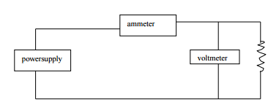
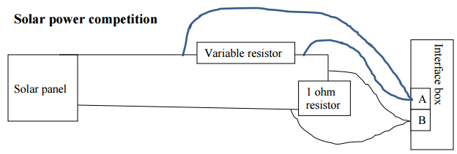

Data:
Part one:

Part two:

Calculations:
Part one:
Mass of water:

∆T:

Q (calories):

Q (Joules):

Percent Error was found using Excel

Qualitative Error Analysis: One error encountered in this lab was that the water in the calorimeter was spilled when being stirred. This could cause the energy required to change the temperature of the water to be lower. Another error in this lab was that it was difficult to keep the thermometer from touching the side of the calorimeter. This could cause the thermometer to read a lower value, as the aluminum would conduct the heat from the inside to the outside.

Quantitative Error Analysis:
Part one:
Percent Error: 1.21%

Results:

Conclusion: This lab was a success, because our percent error was calculated to be 1.21%. The lab was to be considered a success if the percent error if under 20%. One source of error for the lab was the spilling of water in part one, which would cause a higher calculated work than measured. Another error is that the thermometer could hit the side of the calorimetry cup, which would cause the measured temperature to be lower than actual.

